ASSIGNMENT 2:Smartphone Sensor Profiling and Analysis
MOTOROLA EDGE 60 PRO

1. Device Identification
Model: Motorola Edge 60 Pro
Manufacturer: Motorola
Year of Release: 2024–2025 (approx.)
Category: Mid-range / Premium smartphone

2. Operating System Details
OS Name: Android
OS Version: Android 16
UI Layer: Motorola MyUX (near stock Android experience)
Kernel: Linux-based Android kernel

3. Sensor Identification (Using Tools or Apps)
- Accelerometer
- Gyroscope
- Magnetometer (Compass)
- Proximity sensor
- Ambient light sensor
- Fingerprint sensor
- GPS (Location sensor system)
- Microphone (audio input sensor)
- Camera sensors (front and rear)
Screenshot: (Insert from Sensor Box / Device Info HW app)

4. Sensor Classification
Motion Sensors:
Accelerometer
Gyroscope
Position Sensors:
Magnetometer
GPS
Environmental Sensors:
Ambient light sensor
Proximity sensor
Biometric Sensors:
Fingerprint sensor
Imaging Sensors:
Front camera sensor
Rear camera

5. Sensor Details
Sensor Name: Accelerometer
Type: Motion sensor
Vendor: Varies (commonly Bosch or STMicroelectronics)
Unit of Measurement: m/s²
Range: 78.453606 m/s²
Sampling Rate: High (real-time motion tracking)
Use Case: Screen rotation, step counting, motion detection
Sensor Name: Gyroscope
Type: Motion sensor
Vendor: Bosch / STMicroelectronics
Unit: degrees/second
Range: 34.9063 rad/sec
Sampling Rate: High
Use Case: Gaming, AR, camera stabilization
Sensor Name: Ambient Light Sensor
Type: Environmental sensor
Unit: lux
Range: 65535.0 lx
Use Case: Auto brightness control
Sensor Name: Proximity Sensor
Type: Environmental sensor
Range: short distance detection (0–5 cm approx.)
Use Case: Turning off screen during calls
Sensor Name: Fingerprint Sensor
Type: Biometric sensor
Use Case: Device unlocking and security authentication

6. Sensor Data Observation
Sensor 1 Name: Accelerometer
Reading: X = +2.15 m/s², Y = 3.32 m/s², Z = 8.03 m/s²
Condition: Indoor (phone kept in hand)
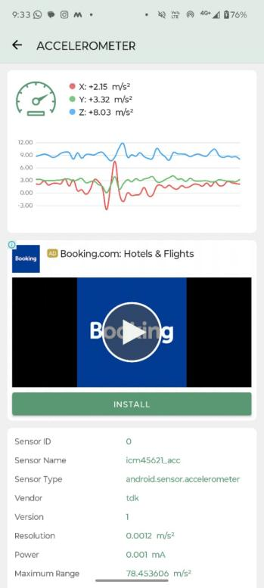
Sensor 2 Name: Light Sensor
Reading: +27.00 lx (approx. indoor lighting)
Condition: Indoor room lighting
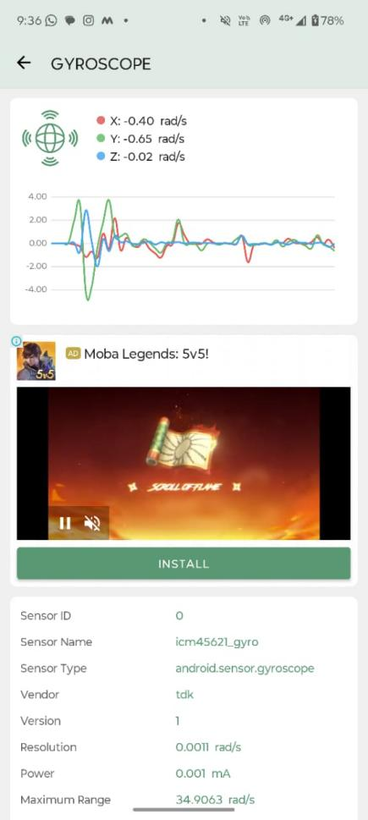

7. Sensor Fusion
Sensor fusion is the combination of data from multiple sensors to improve accuracy and performance.
For example, the accelerometer and gyroscope work together to detect precise motion and orientation of the phone. GPS and magnetometer combine to improve navigation accuracy in maps. This helps in applications like gaming, fitness tracking, AR apps, and navigation systems.

8. IoT Perspective
Smartphone as Edge Device:
The smartphone collects real-time data from sensors, processes it locally, and responds immediately without needing external systems.
Smartphone as Gateway:
It transfers sensor data to cloud services using Wi-Fi or mobile data and connects with other IoT devices like smartwatches, smart home devices, and Bluetooth sensors.

9. Critical Analysis
Missing Sensors:
leaser autofocus,selfie camera autofocus ,barometer
Power Consumption Issues:
Sensors like GPS and gyroscope consume more battery when used continuously.
Cost vs Sensor Quality:
Higher-end smartphones have more accurate and faster sensors compared to mid-range devices.
Limitations / Accuracy:
Sensor readings may be affected by noise, calibration errors, and environmental interference.

10. Conclusion
The Motorola Edge 60 Pro contains multiple advanced sensors that allow it to interact with the physical environment. These sensors help in motion tracking, navigation, security, and environmental awareness. Overall, the smartphone acts as a powerful IoT edge device by sensing, processing, and transmitting real-world data efficiently.

